Homework #08

Convective Boundary Conditions

**Problem 1: Derive the one-dimensional equation**

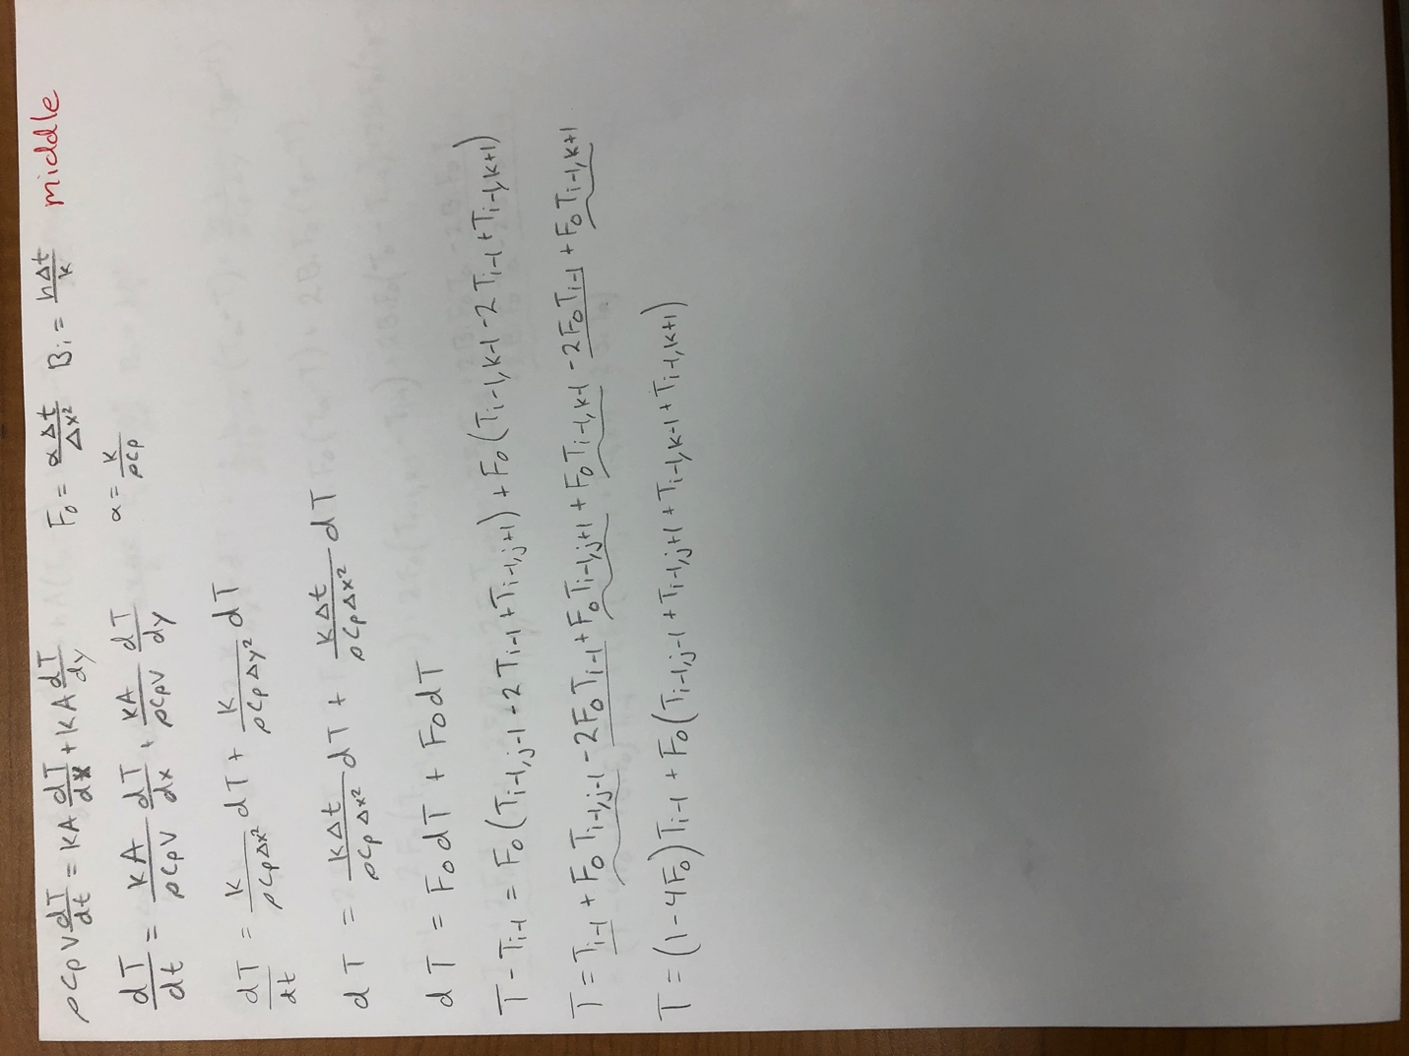

**Problem 2: Derive the equation for a 2-D plane surface with convection**

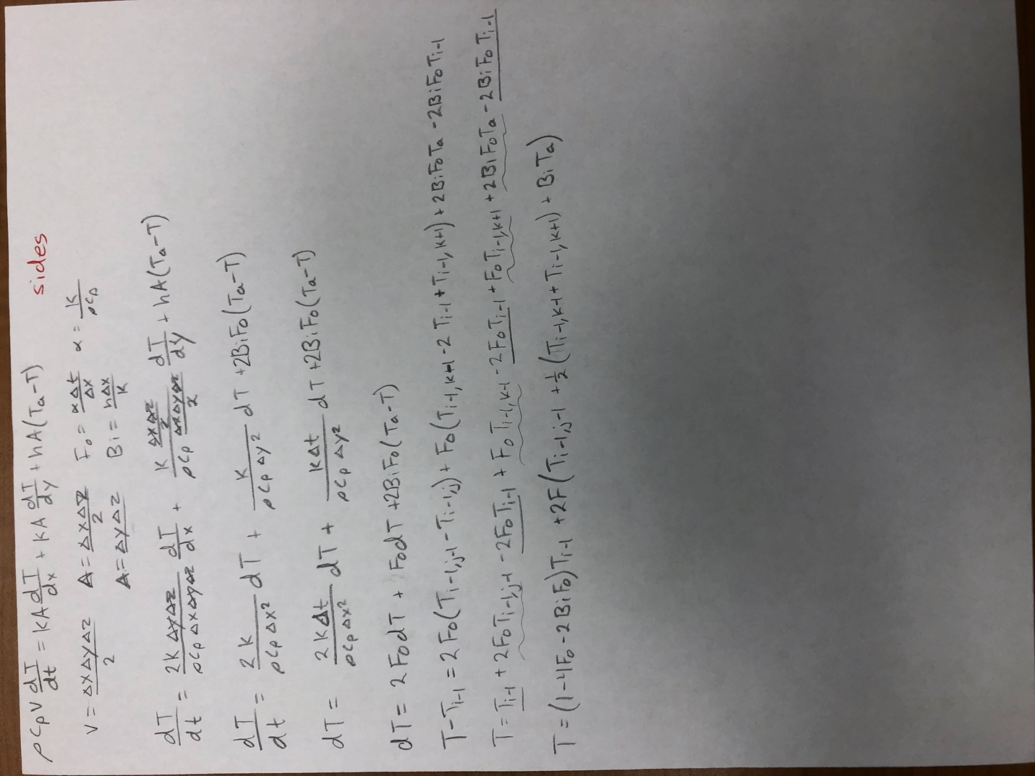

**Problem 3: derive the equation for the exterior corner**

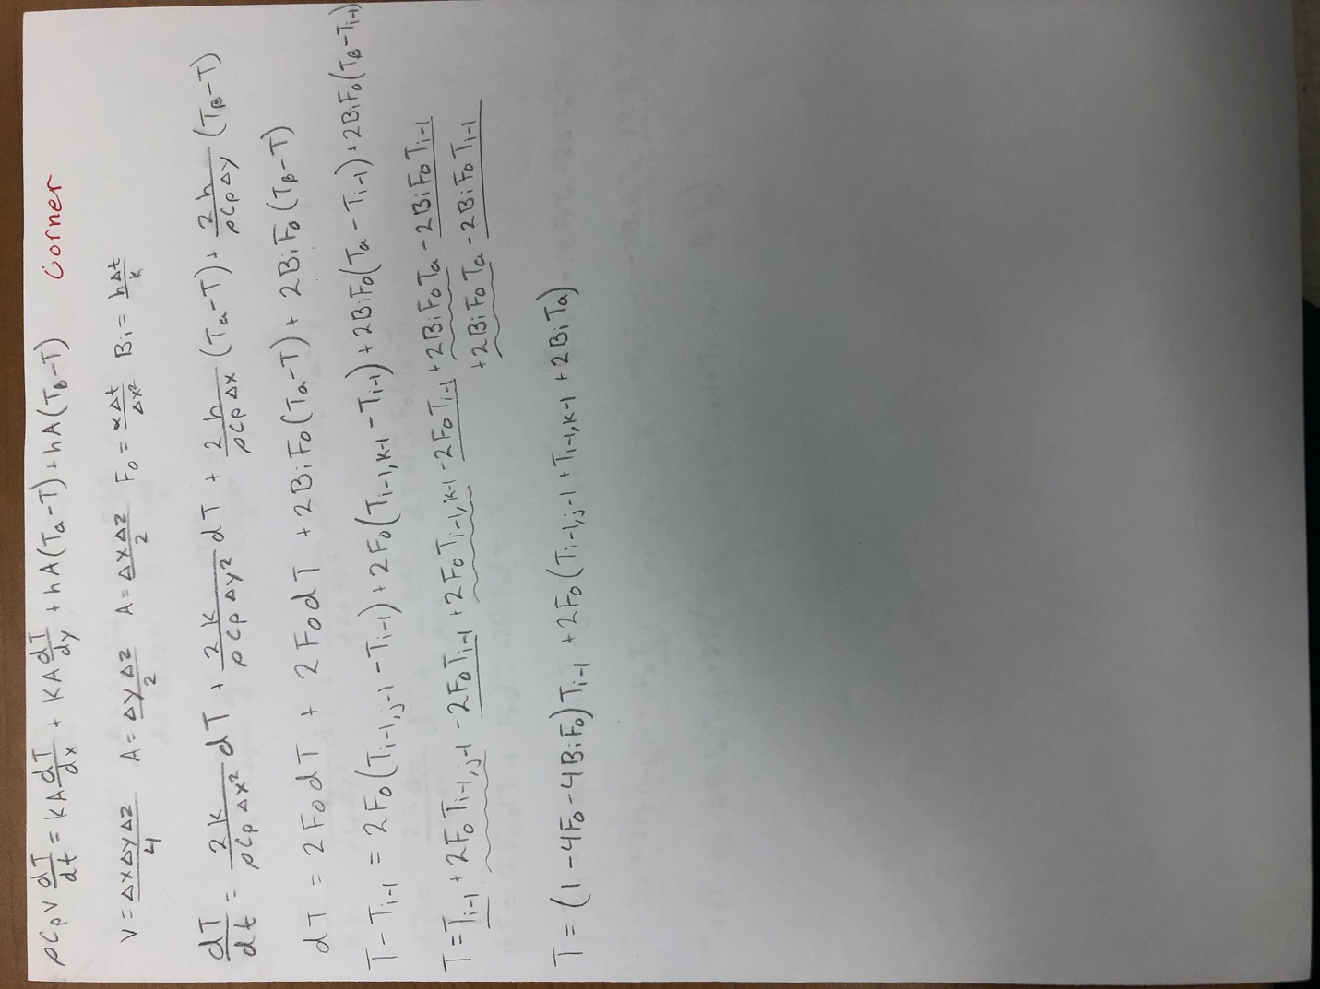

**Problem 4: Snickers Bar**

Equations Used:

eqTSide(snickerBlock,fo,bi,j,k,ambientTemp)

eqBSide(snickerBlock,fo,bi,j,k,ambientTemp)

eqLSide(snickerBlock,fo,bi,j,k,ambientTemp)

eqLCorner(snickerBlock,fo,bi,j,k,ambientTemp)

eqRCorner(snickerBlock,fo,bi,j,k,ambientTemp)

eqRSide(snickerBlock,fo,bi,j,k,ambientTemp)

eqLBCorner(snickerBlock,fo,bi,j,k,ambientTemp)

eqRBCorner(snickerBlock,fo,bi,j,k,ambientTemp)

eqCenter(snickerBlock,fo,j,k,ambientTemp)

Temperature Profile Plots:

How long does the tunnel need to be?

Time=199.1s*(1min/60s)=3.318min

Length = 1m/min*(3.318min) = 3.318meters